Experiment 1
Title: Responsive Web Page using Bootstrap Grid System
ProblemStatement:
Create a basic web page containing a header, navigation bar, content section, and footer.
Use Bootstrap grid system (rows and columns) and breakpoints to make the page responsive.
Create a responsive web page containing:
- Header Section
  - Website Title
- Navigation Bar
  - Home
  - About
  - Services
  - Contact
- Content Section
  - Two columns on medium and large screens
  - Single column on small screens
- Footer Section
  - Copyright text
Requirements:
- Use Bootstrap grid system
- Use rows and columns
- Apply breakpoints
- Page should adjust properly on mobile and desktop
Objective
After completing this experiment, students will be able to:
- Understand responsive web design
- Use Bootstrap grid system
- Apply rows and columns
- Use breakpoints (col-sm, col-md, col-lg)
- Create structured layouts

Covers Syllabus:
- Bootstrap grid layout
- Breakpoints & responsiveness
- Containers, rows, columns
Expected Outcome:
A responsive webpage that adjusts layout for mobile and desktop screens.
Tools: HTML, Bootstrap
————————————————————————————————
Objective
After completing this experiment, students will be able to:
- Understand responsive web design
- Use Bootstrap grid system
- Apply rows and columns
- Use breakpoints (col-sm, col-md, col-lg)
- Create structured layouts
ProblemStatement:
Create a basic web page containing a header, navigation bar, content section, and footer.
Use Bootstrap grid system (rows and columns) and breakpoints to make the page responsive.
Create a responsive web page containing:
- Header Section
  - Website Title
- Navigation Bar
  - Home
  - About
  - Services
  - Contact
- Content Section
  - Two columns on medium and large screens
  - Single column on small screens
- Footer Section
  - Copyright text
Step 1: VS Code में Folder बनाइए
- VS Code open
- File → Open Folder
- New folder Create
folder Name (like bootstrap)
Step 2: HTML File Create
Folder →New File
index.html
Step 3: Vs Code Program Run
<!DOCTYPE html>
<html>
<head>
<title>Responsive Web Page using Bootstrap Grid</title>
<meta name="viewport" content="width=device-width, initial-scale=1">
<!-- Bootstrap CSS -->
<link rel="stylesheet" href="https://cdn.jsdelivr.net/npm/bootstrap@5.3.2/dist/css/bootstrap.min.css">
<style>
header{
background-color:#0d6efd;
color:white;
text-align:center;
padding:15px;
}

footer{
background-color:#333;
color:white;
text-align:center;
padding:10px;
margin-top:20px;
}
</style>
</head>
<body>
<!-- Header -->
<header>
<h2>My Website</h2>
</header>
<!-- Navigation -->
<nav class="navbar navbar-dark bg-dark navbar-expand-lg">
<a class="navbar-brand ms-3" href="#">Website</a>
<ul class="navbar-nav ms-auto me-3">
<li class="nav-item">
<a class="nav-link" href="#">Home</a>
</li>

<li class="nav-item">
<a class="nav-link" href="#">About</a>
</li>
<li class="nav-item">
<a class="nav-link" href="#">Services</a>
</li>
<li class="nav-item">
<a class="nav-link" href="#">Contact</a>
</li>
</ul>
</nav>
<!-- Content -->
<div class="container mt-4">
<div class="row">
<div class="col-md-6 col-sm-12">
<h4>Column 1</h4>
<p>
This is the first column.
On small devices the column occupies full width, while on medium and large devices it occupies half width using Bootstrap grid classes. </p>
</div>
<div class="col-md-6 col-sm-12">
<h4>Column 2</h4>
<p>
This is the second column.
Bootstrap grid system helps to create responsive layout.
</p>
</div>
</div>
</div>
<!-- Footer -->
<footer>
<p>Copyright © 2026 My Website</p>
</footer>
</body>
</html>

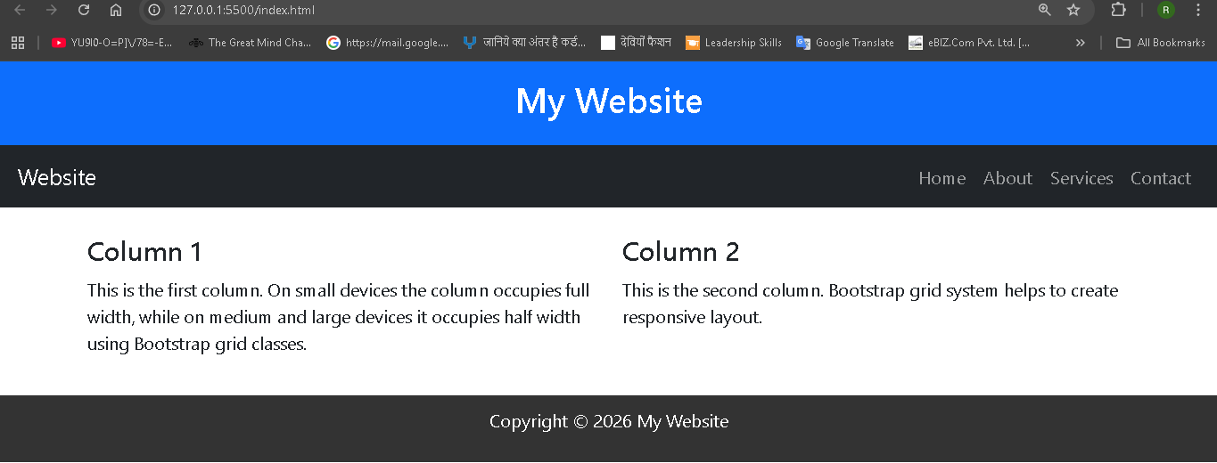

<!-- Footer -->
<footer>
<p>Copyright © 2026 My Website</p>
</footer>
<!-- Bootstrap JS -->
<script src="https://cdn.jsdelivr.net/npm/bootstrap@5.3.2/dist/js/bootstrap.bundle.min.js">
</script>
</body>
</html>

